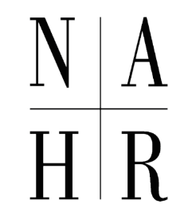

*Established in 1992*

**Founding Members of the National Academy of Human Resources**

Richard A. Beaumont

Walton E. Burdick*

Harold W. Burlingame*

Bruce Carswell*ƚ

Frank P. Doyle*

Clifford J. Ehrlich

Bruce R. Ellig

Ursula O. Fairbairn

Fred K. Foulkes

Madelyn P. Jennings*

J. Roger King

Howard V. Knicely*

David Lewin

David P. Lipsky

Michael R. Losey

D. Quinn Mills

Kenneth L. Otto

Dallas L. Salisbury

Christopher J. Wheeler ƚ

*\*Distinguished Fellows*

*ƚDeceased*